Personnel Committee
April 15, 2015 ~ 12:00 PM ~ Administrative Board Room

Committee Members Present: Weldon Smith, Chairman, Don Lewis, Susan Kanard
Committee Members Absent: Cara Bland, Evans McBride
Hospital Staff Present: Scott Lowe, HR Director; Deborah Sherwood, HR Assistant
Other: None
“Privileged and Confidential pursuant to 63 O.S. 1-1709.1 and/or 63 O.S. 1-1709.”
Topic/Finding |  | Discussion |  | Recommendation/Action | Follow-up/ Responsible Party
Call to order: |  | Chairman Smith called the meeting to order at 12:02pm.
Approval of Minutes: |  | Motion to approve minutes from August 12, 2014 by Weldon Smith, Seconded by Don Lewis. Minutes approved
Old Business:
 |  | No old business
New Business:
- David Keith, CEO contract | Mr. Smith stated the key question was is “Do we want to continue David Keith’s employment?” It was agreed that we do want to continue with David Keith’s employment.  Weldon asked Scott “Where do we stand on bonuses?” Scott replied that David’s hospital bonus threshold was 30% in his contract. It had a threshold of 10% based on the hospital making its trigger points. Mr. Smith asked what the EBIDA trigger was. Scott said it was 60 and that we did meet the EBIDA, it was at 105%. Weldon asked what the other requirements were :  Stewardship – the trigger:  - EBITDA Margin % of 11.1%  - Defined as: (Net Operating Income + Depreciation) / Net Operating Revenues.  - Source : Audited financials  - Baseline: FY13 @ 7.1%, FY14 @ 9.1%, BY15 Target 11.1%  - Net Revenue Collection Ratio (NRCR%)  - Defined as: Cash Receipts / Net Operating Revenues  - Source : Audited financials  - Baseline: FY13 @ 104%, FY14 @ 108%, BY15 Target 102%  Target: EBIDA Margin 11.1%, NRCR% 102%  Target Plus: EBIDA Margin 12.0%, NRCR% 103%  Quality:  - Clinical Process of Care  - SCIP (Surgical Care Improvement Plan): – Inf – 2  - Definition: Prophylactic Antibiotic Selection for Surgical Patients  - Source: CMS Reporting and VHA Value Analyzer.  - Baseline: The MRHC most current published results to CMS as of 2Q2013 is 96.2%.  Target: 99  (Moving from 96 to 99 is when MRHC begins to achieve monetary award)  Target Plus: 100  (Moving from 99 to 100% MRHC achieves the greatest monetary opportunity of all clinical process of care measures.)  Quality  - Outcomes Measure  - AMI (Acute Myocardial Infarction) 30 Day Survival Rate  - The 30 day mortality measures assess deaths that occur within 30 days after admission, which, depending on the length of stay, may occur post-discharge.  - Source : Centers for Medicare & Medicaid Services, & VHA Analyzer  - Baseline: Baseline: The MRHC most current published results to CMS as of 2Q2013 is 76%.  Target: 77%  (Moving from 76 to 77% is when MRHC begins to receive monetary award)  Target Plus: 79%  (by moving from 76 to 79% is when MRHC receives the greatest monetary award within this area)  Customer Service:  - Patient Experience of Care Measure  - Clean and Quiet  - Indicator Definition:  - During this hospital stay, how often were your room and bathroom kept clean?  - During this hospital stay, how often was the area around your room quiet at night?  - Source: HCAHPS Survey Data submission & VHA Value Analyzer.  - Baseline: Results as of 2Q2013 are: Clean 72%, Quiet 54%  Target: Clean 74%, Quiet 56%  (Moving from 72 to 74% Clean and 54 to 56 Quiet is when MRHC begins to receive a monetary award )  Target Plus: Clean 80%, Quiet 60%  (Moving from 72 to 80% Clean and 54 to 60% quiet is when MRHC potential $3000 monetary award)  RN Communication:  - Patient Experience of Care Measure  - RN Communication  - Indicator Definition  - During this hospital stay, how often did nurses treat you with courtesy and respect?  - During this hospital stay, how often did nurses listen carefully to you?  - During this hospital stay, how often did nurses explain things in a way you could understand?  - During this hospital stay, after you pressed the call button, how often did you get help as soon as you wanted it?  - Source: CMS Reporting and VHA Value Analyzer  - Baseline: MRHCs most current published results to CMS as of 2Q2013 are 74%  Target: 78  (Moving from 74 to 78% is when MRHC begins to achieve monetary award)  Target Plus: 80  (by moving from 78 to 82% is when MRHC potential of $6000 monetary award)  Discharge Instructions:  - Patient Experience of Care Measure  - Discharge Instructions  - Indicator Definition:  - After you left the hospital, did you go directly to your own home, to someone else’s home, or to another health facility?  - During this hospital stay, did doctors, nurses or other hospital staff talk with you about whether you would have the help you needed when you left the hospital?  - During this hospital stay, did you get information in writing about what symptoms or health problems to look out for after you left the hospital?  - Source: CMS Reporting and HVA Value Analyzer  - Baseline: The MRHC most current published results to CMS as of 2Q2013 is 76%.  Target: 79  (Moving from 76 to 79% is when MRHC begins to achieve monetary award)  Target Plus: 84  (Moving from 76 to 84% is when the MRHC potential $6000 monetary award)  Target Grid:  OUTCOME GOAL TARGET TARGET PLUS  Stewardship EBIDA Margin Net Revenue Collection Ratio 11.1% 102% 12.0% 103%  SCIP-Inf-2 (Surgical Care Improvement Plan) 99% 100%  AMI 30 Day Survival Rate (Acute Myocardial Infarction) 77% 79%  Clean & Quiet 74%, 56% 80%. 60%  RN Communication 78% 80&  DC Planning 79% 84%  Scoring Grid – AET:  OUTCOME GOAL TARGET TARGET PLUS  Stewardship EBIDA (Trigger) Net Revenue Collection Ratio 10 15  SCIP-Inf-2 2 3  AMI 30 Day Survival Rate 2 3  Clean & Quiet 2 3  RN Communication 2 3  DC Planning 2 3  Total Percentage 20% 30%  HOW WE DID:  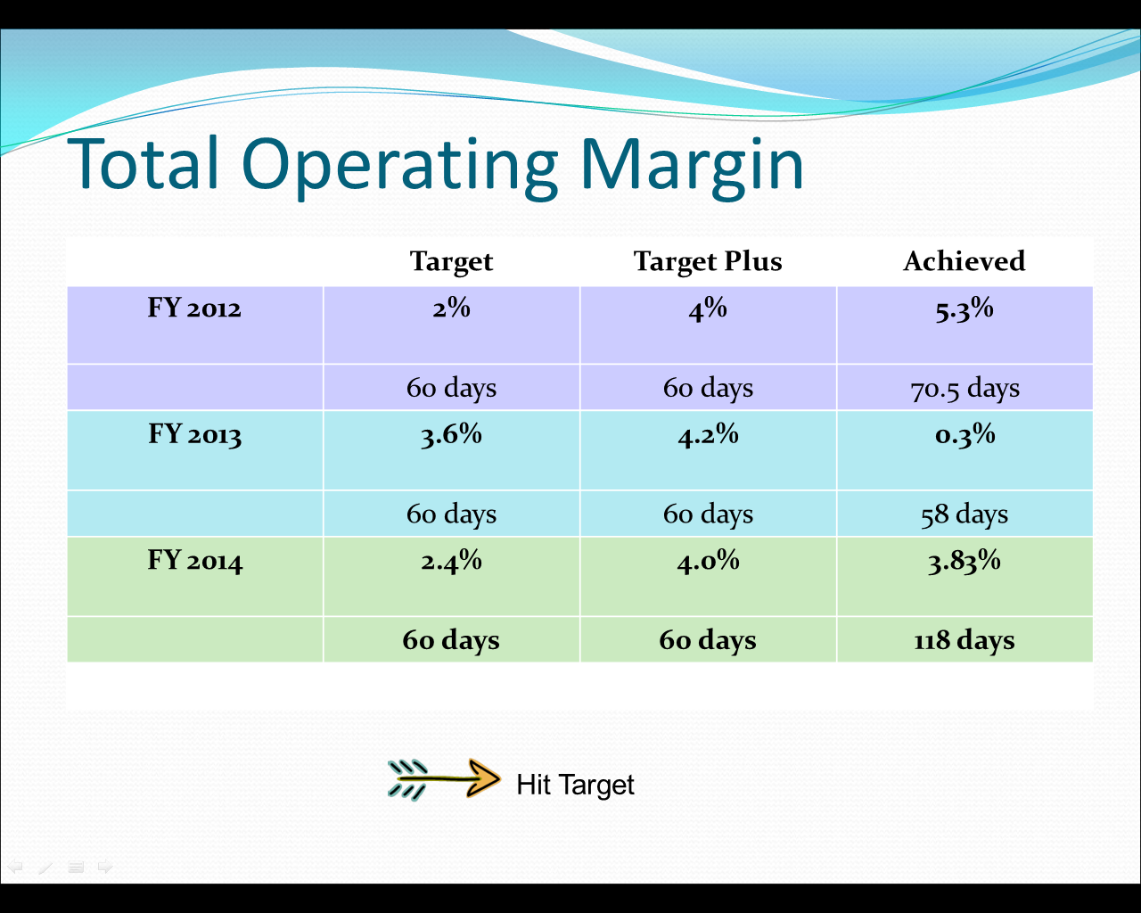  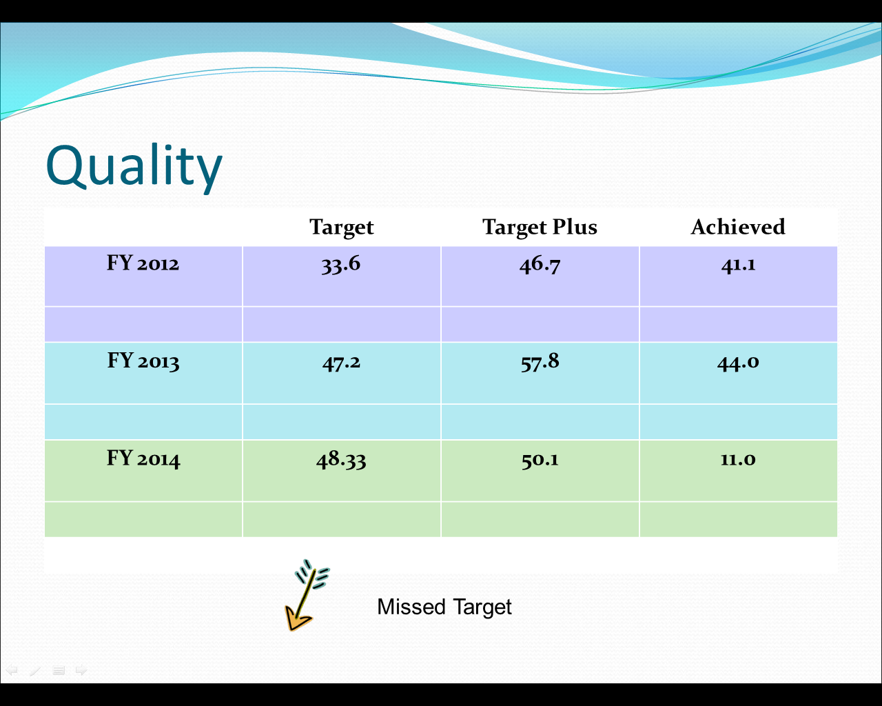  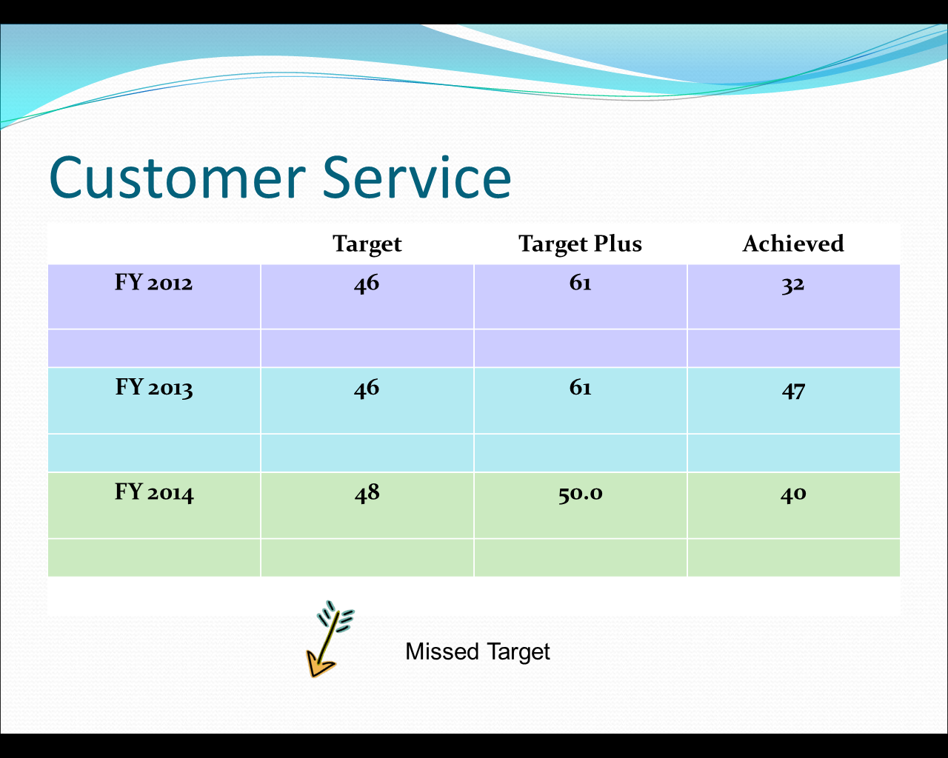  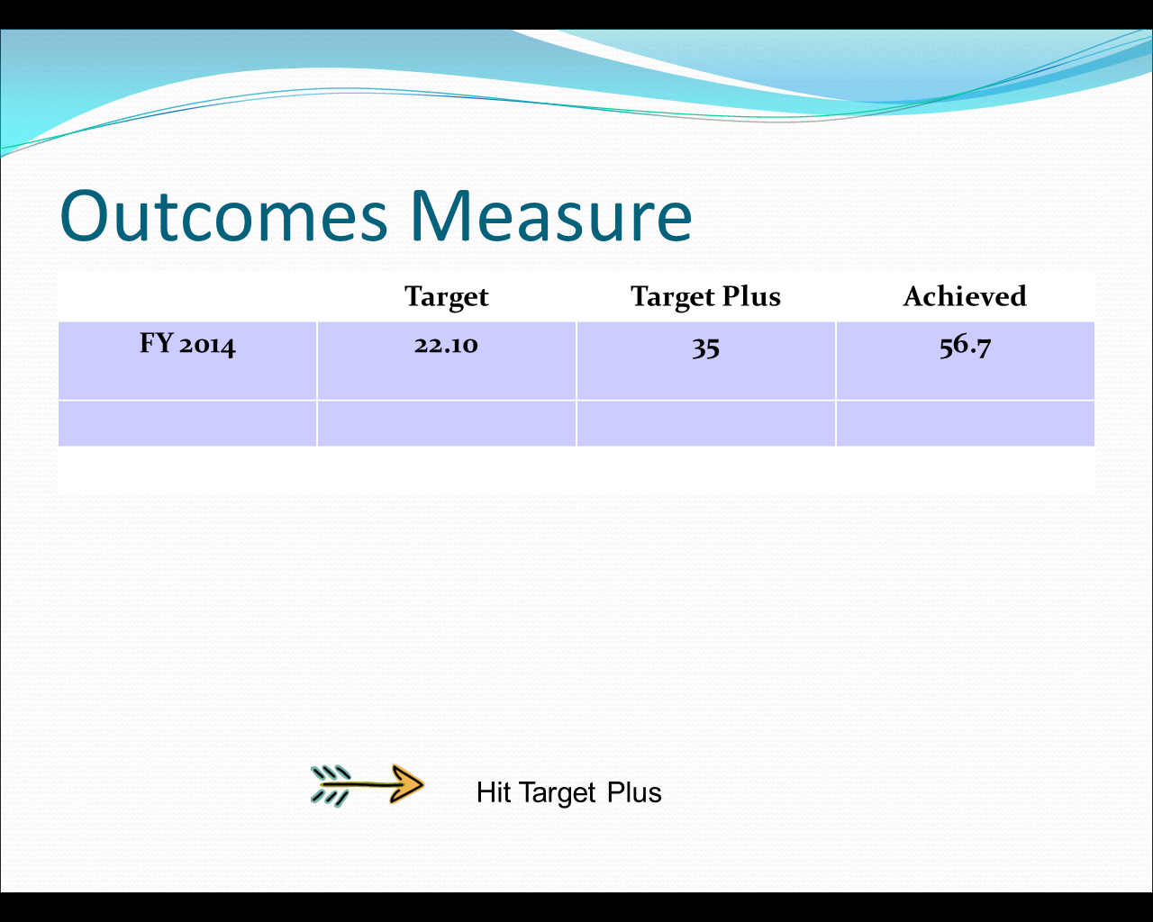  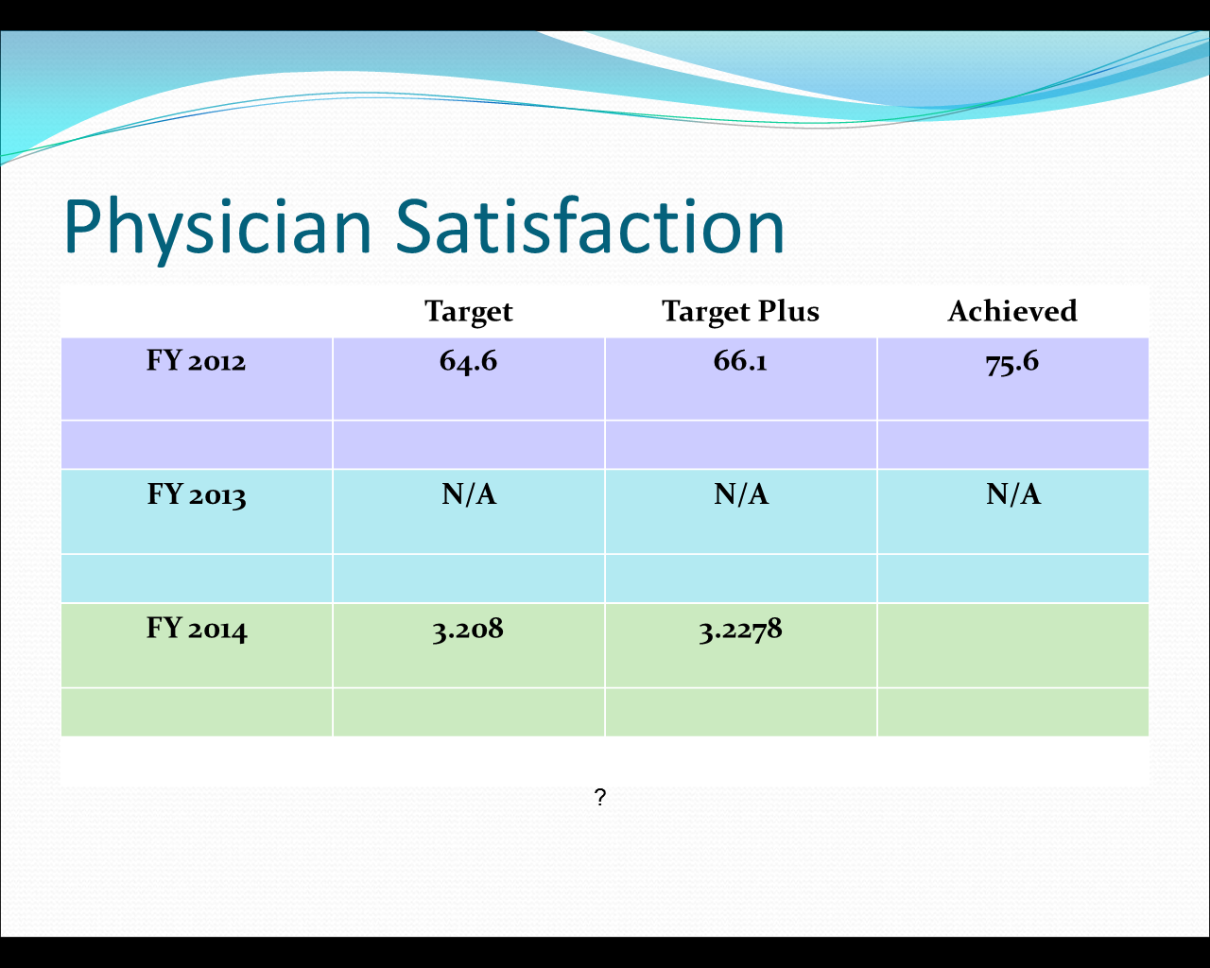  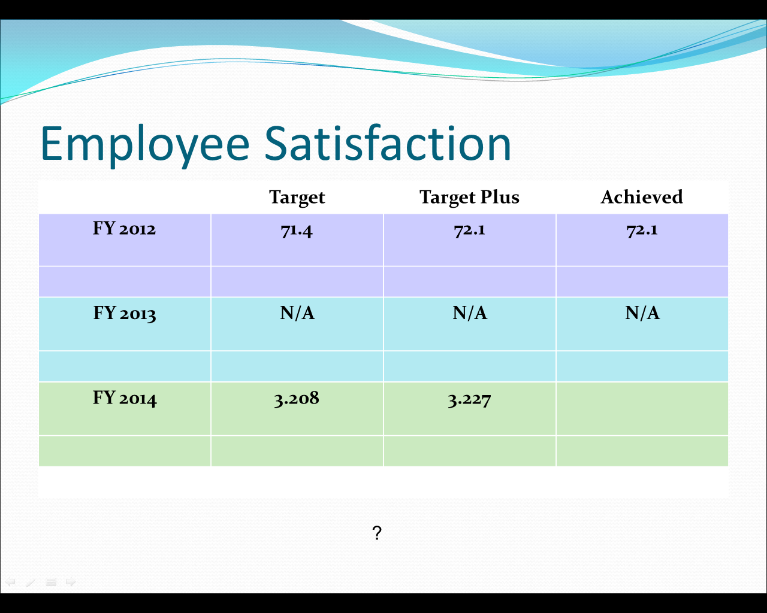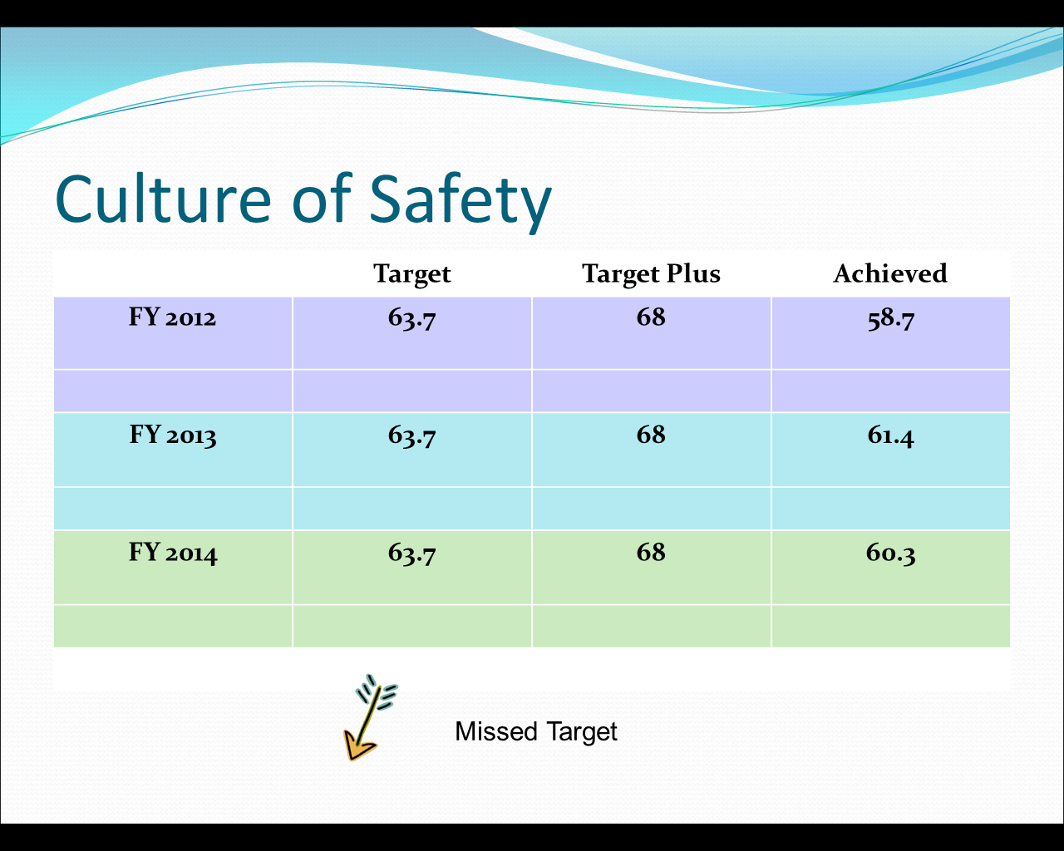  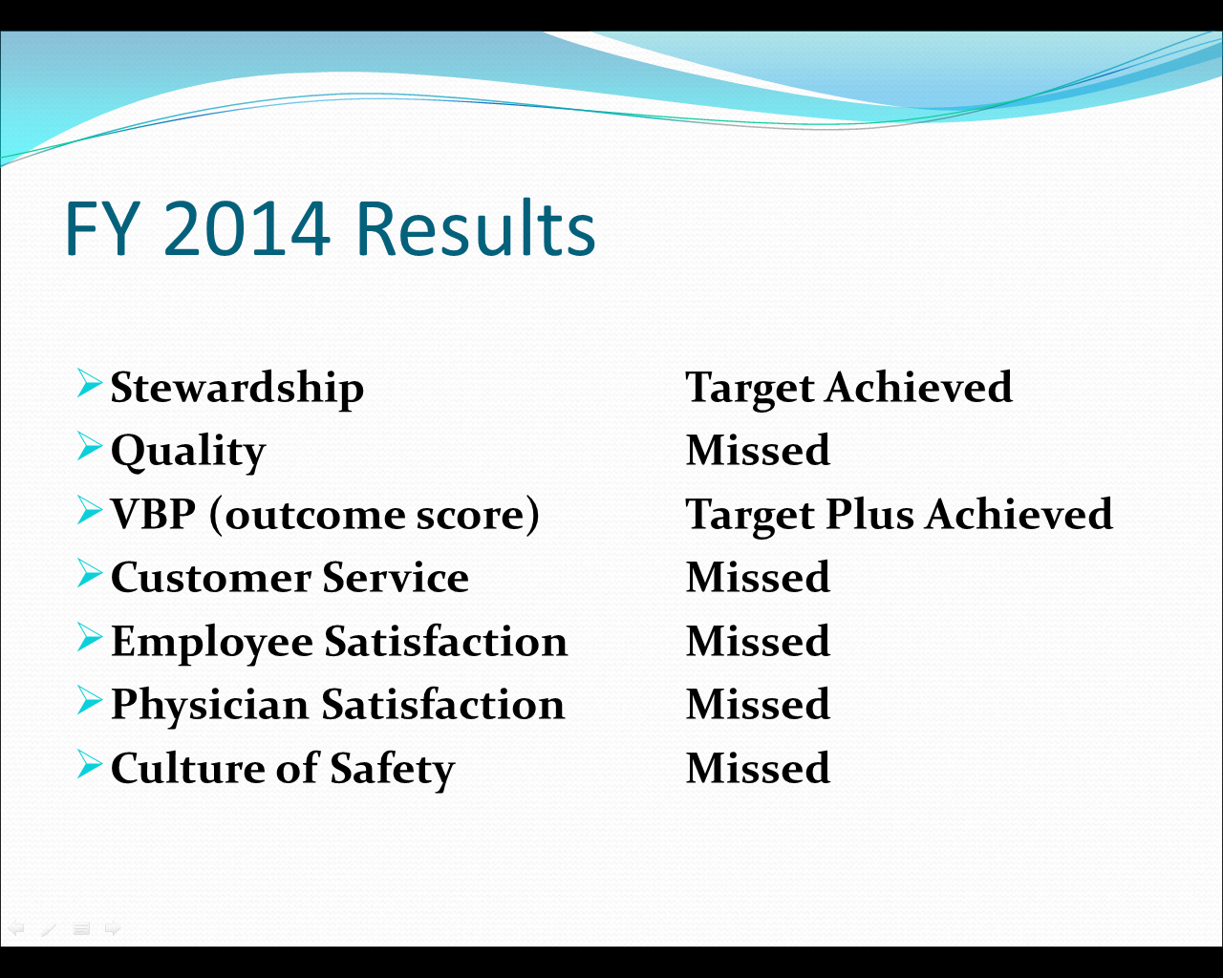  VBP (Value Based Purchasing)  Target: 22.10  Target Plus: 35  Achieved: 56.7  Weldon would like to get comparisons, from other Net Revenue comparable hospitals, of what their CEO’s salaries are. Scott said he has not received all of the responses yet but he did have Stillwater.  Jerry Miller, CEO  Base $276,261  Bonus $ 25,850  Total $302,111  Before the next board meeting. Weldon would like to know more CEO comparable salaries. Including their bonuses. Not just what they made in bonuses but what the total potential is. Susan Kanard asked if there are any hospitals closer to us than Stillwater. Scott said he is looking and should have some comparisons soon and that he is trying to get Duncan to respond. Scott said the CEO there moved from Stillwater and he believes his salary is $320,000 but has not confirmed it yet. Weldon stated that the problem is that many hospitals have been bought by private hospital chains and we need to make sure that we compare to public hospitals. Susan recommended Tahlequah. Weldon said to make sure we compare to hospitals with the same net revenue to ours. We are around $80 million net revenue.  Weldon asked if they liked the basic structure of how the bonus is set up. They agreed right now 30% seems good. Don stated we need to be careful of changing percentages and Weldon said we were not changing anything in the middle of the year. They were looking at any changes that may need to be made going forward to the next year. Weldon said “the only thing he is asking is if those percentages of the bonuses are ok?  Weldon also stated that he was glad that the error on disability was noticed. Scott said David’s current contract states that disability is paid at 100% of salary. Disability only pays at 60% and the hospital would have had to make up the difference. Don said that would run for 12 months? Scott said correct, you have a 90 day occupation provision which means he cannot perform is regular occupation for 90 days to qualify. Weldon said we also have a no compete clause.  Weldon mentioned 5.2 in regards to David’s life insurance policy. Where we were saying 3 times annual base pay but then we found out that $650,000 is the max.  Don asked what the difference in a 401k and 401a is. Scott stated that it is the type of employer. The 457e is the employee’s portion and the employers match goes into the 401a portion.  Weldon stated that on the revisions to David’s contract, David is requesting a 5 year term. Weldon thinks it is good to want a 5 year contract but 5 year seems a bit much. Don stated that it would be a 5 year contract but it is renewable each year. Weldon would like to suggest a 3 year contract. It is currently a 2 year contract. If we would approve it each year it would give him another 3 years. Scott said if we have a contract term. When is his contract really ending if it is always going 3 years out? Weldon said that no board can obligate another board. Weldon said we need to talk to legal to get the wording right. That as long as we like his work, we should always have a 3 year timeline in front of him. But each year we want to renew that for another 3 years. Scott said “basically he would always have 3 years in front of him should we ever decide not to renew his contract.”  Weldon stated that what David is asking is an 11% raise. But what we gave our employees a 2% raise last year and have budgeted for another 3.5% raise this year. Weldon said he would feel more comfortable offering a 5% increase rather than 11%. Scott stated besides the merit increases for employees they are also doing market increases. Weldon stated that the employees have gotten zip for the last few years but David got a pretty good bump last year and that is Scott’s research shows he is already close to market rate. Scott said that David is actually under market rate at the moment. Weldon then said he would feel better with only a 5% increase. Susan agreed that 5% is appropriate. Don said we 5% may be fair but we need to see all the dollars and cents on it because it might not be the right figure yet. Weldon said on the other hand if the board feels that he has done things worthy of a raise then they would relook at it. Weldon said we want to be sure to retain David. Don agreed and said it was a pretty good contract above all and he didn’t know of many areas that needed changes.  Weldon said we need to know what David’s base pay was each year. David has been pretty amendable with not getting more than the employees have received each year.  Susan mentioned that when the employees got the second 1% raise last year, the employees at the ASC did not get it. Because they are not entirely owned by the hospital. Weldon said it was because we are only 50% owners and Saint Francis would not go along with the raises. Susan said they should have been worth that 1% to the hospital just like any other nurse. There are very few nurses left at the ASC.  Weldon proposed that they wait for more wage comparisons and meet again to go over what other CEO’s are making before making any offers to David. The Personnel Committee will meet again on April 23rd at noon to go over the comparisons. |  |  | Why did BY15 go down to 102%  Weldon would like specific % of what all of the AET team gets if we hit target plus on everything. Does everyone get 30% or just David?  Achieved 3.05  VBP=Value Based Purchasing  Get more comparables from more hospitals in the area of our size.  We need to make sure the wording is ok. | Scott Lowe
Other Business:
ADJOURNMENT: |  | No further business was brought before the Committee for discussion. | The meeting was adjourned at 1:41pm.

______________________________________
Weldon Smith, Chairman

